**Comprehensive Digital Marketing Strategy for Fabindia**

**1. Brand Study, Competitor Analysis & Buyer’s/Audience’s Persona**

**Goals:**

* Understand Fabindia’s brand positioning and unique selling

proposition (USP).

* Analyze key competitors in the ethnic and sustainable fashion industry.
* Identify target audience segments based on demographics, psychographics, and behavior.

**Strategies:**

* Conduct SWOT

analysis for Fabindia and its competitors.

* Use customer surveys and data analytics for audience segmentation.
* Develop detailed buyer personas (e.g., eco-conscious shoppers, fashion-forward consumers, and traditional wear enthusiasts).

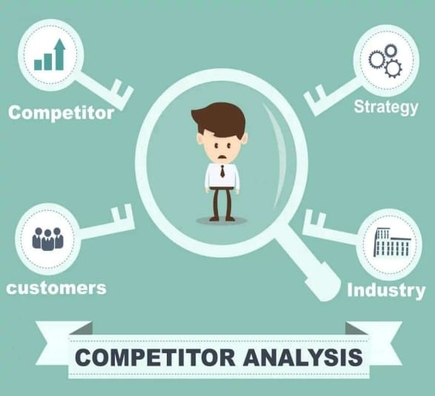

**2. SEO & Keyword Research**

**Goals:**

* Improve organic search rankings and website visibility.
* Optimize content for

high-intent keywords related to ethnic wear, home décor, and sustainability.

**Strategies:**

* Conduct keyword research using tools like Google Keyword Planner and SEMrush.
* Optimize product pages, blogs, and metadata with targeted

keywords.

* Implement structured data markup for better search engine understanding.

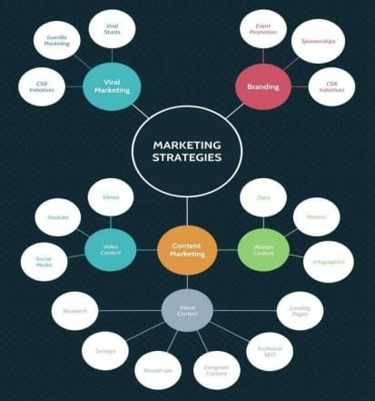

**3. Content Ideas & Marketing**

**Strategies**

**Goals:**

* Create engaging and informative content that drives brand awareness.
* Position Fabindia as a thought leader in sustainable fashion and lifestyle.

**Strategies:**

* Develop a blog series

on sustainable fashion trends and traditional crafts.

* Utilize video content for storytelling (e.g., artisan interviews, behind-the-scenes footage, and styling guides).
* Launch interactive content such as quizzes (e.g., “Which

Fabindia Style Suits You?”).

* 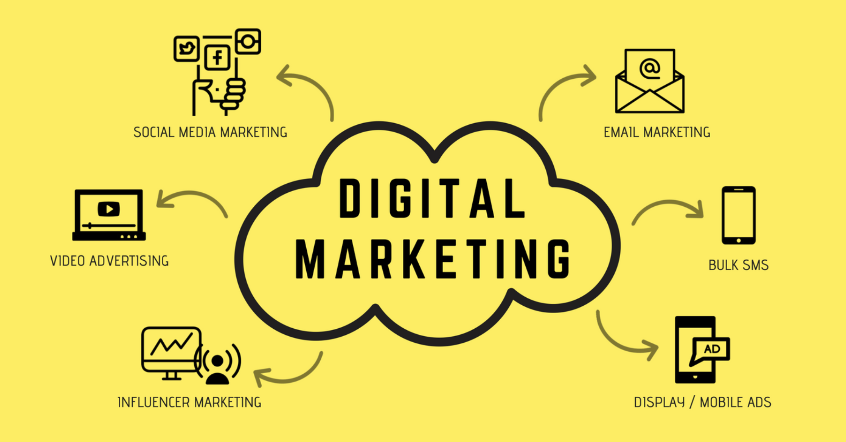

**4. Content Creation & Curation**

**Goals:**

* Maintain a consistent brand voice and aesthetics across platforms.
* Showcase Fabindia’s craftsmanship and sustainability initiatives.

**Strategies:**

* Collaborate with photographers and content creators to produce high-quality visual content.
* Leverage user-generated content by encouraging customers

to share their Fabindia looks.

* Publish seasonal lookbooks and festive collection previews.

**5. Social Media Marketing**

**Goals:**

* Enhance community engagement and brand recall.
* Drive traffic to

Fabindia’s website and offline stores.

**Platform Strategies:**

* **Instagram & Pinterest:** Showcase aesthetic product visuals, DIY styling tips, and sustainability stories.
* **Facebook:** Promote offers, live sessions, and customer testimonials.
* **YouTube & Reels:** Feature craft processes, styling guides, and influencer collaborations.
* **LinkedIn:** Share business achievements, sustainability initiatives, and corporate news.



**6. Paid Advertising (Performance Marketing)**

**Goals:**

* Increase website traffic and conversions.
* Retarget interested customers for higher sales.

**Channels:**

* **Google Ads:** Run search ads, display ads, and shopping ads for Fabindia’s product categories.
* **Meta Ads (Facebook & Instagram):** Implement carousel ads, video ads, and retargeting campaigns.
* **Influencer**

**Collaborations:** Partner with fashion, sustainability, and lifestyle influencers for wider reach.

**7. PR & Online Reputation Management**

**Goals:**

* Build credibility and positive brand sentiment.
* Manage brand perception effectively.

**Strategies:**

* Collaborate with fashion and lifestyle publications for feature articles.
* Monitor online reviews and engage with customer feedback.
* Publish CSR initiatives and sustainability

efforts through PR campaigns.

* 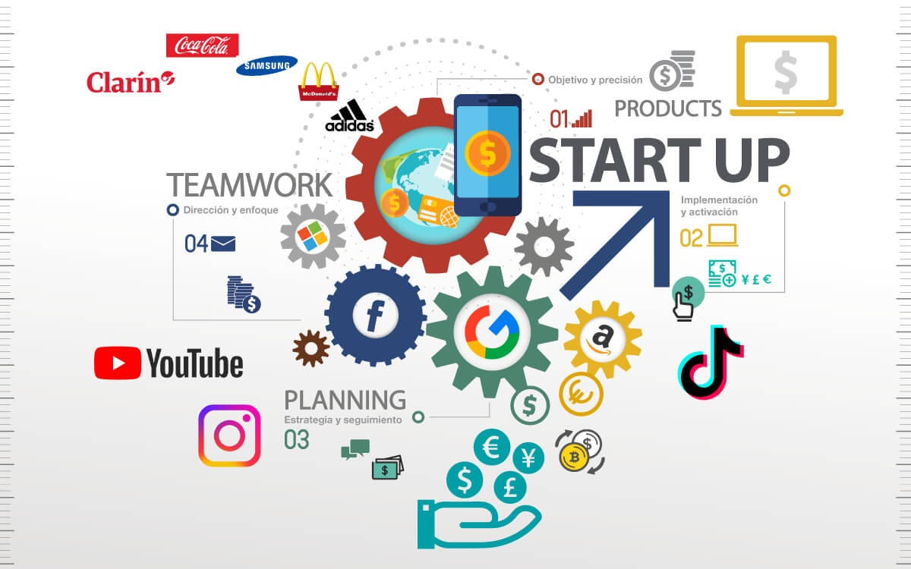

**8. Data & Analytics**

**Goals:**

* Track performance metrics for continuous optimization.
* Improve customer

journey through data-driven decisions.

**Tools:**

* Google Analytics for website performance insights.
* Heatmaps and session recordings for user behavior analysis.
* Social media analytics to measure engagement and ROI.

**Conclusion**

By implementing a comprehensive digital marketing strategy, Fabindia can strengthen its brand presence, enhance customer engagement, and drive sustained growth in the competitive market. A holistic approach combining SEO, content

marketing, social media, paid advertising, and analytics will ensure long-term success.